

**PROJECT REPORT TEMPLATE**

**1 INTRODUCTION**

* 1. Overview

Designing a social media post using Canva

* 1. Purpose

We created a aocial media post for our college onam celebration

1. **PROBLEM DEFINITION & DESIGN THINKING**
   1. Empathy Map

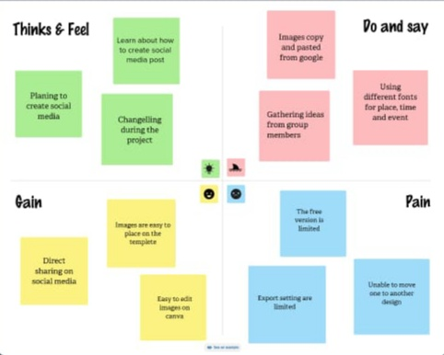

* 1. Ideation & Brainstroming

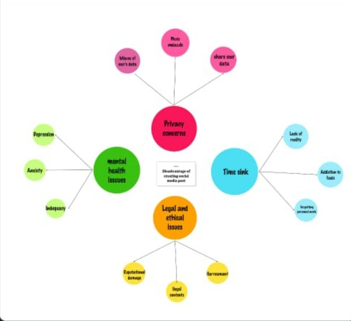

1. **RESULT**

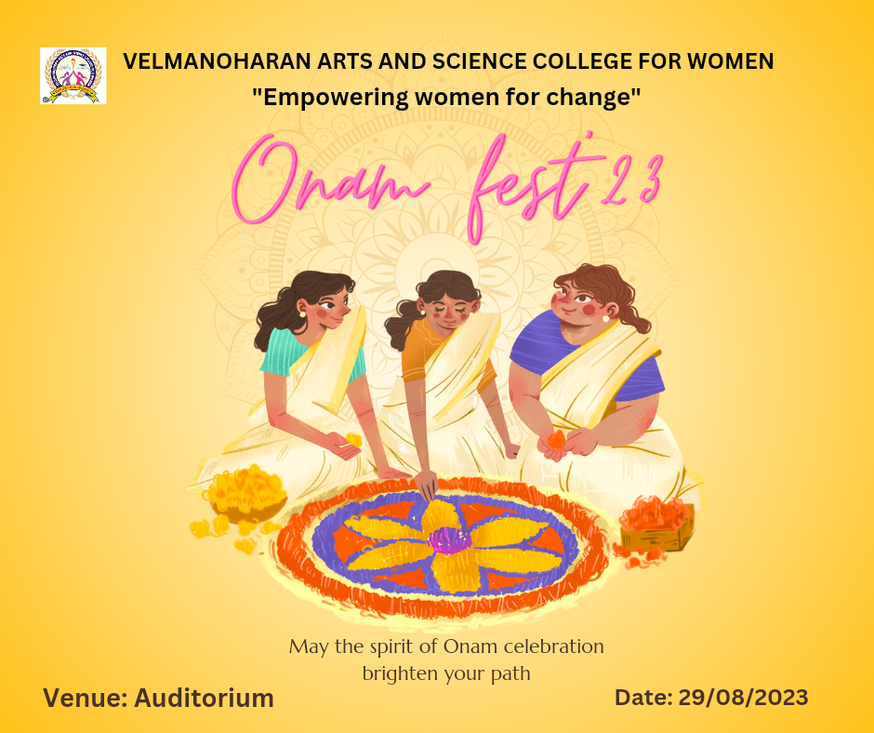

1. **ADVANTAGES AND DISADVANTAGES**

It was helpful to create social media post attract targeted audience

The disadvantage of creating social media post in canva is limitation of templates

1. **APPLICATIONS**

It is useful to create social media post to attract views

1. **CONCLUSION**

Canva is helpful app to create and edit content. It enhances our creative skills. It is user friendly app. In this app, we can access tools for editing very easily.